Momentum: A Crash Lesson
An object’s momentum depends on both its mass and its velocity. Momentum can be expressed by the formula
p = mv
where p = momentum (in g•m/s), m = mass (in g), and v = velocity (in m/s). Momentum is an important factor in analyzing collisions, especially those of automobiles. In this experiment, you will study the relationship between a car’s momentum and the distance it pushes an object during a collision. You will use a balance or spring scale to measure the car’s mass (m) and a computer-interfaced Motion Detector to measure its velocity (v). You will then calculate momentum (p) using the formula given above.

OBJECTIVES
In this experiment, you will
- Use a computer to measure velocity.
- Measure mass.
- Calculate momentum.
- Graph data.
- Make conclusions about momentum.

MATERIALS
computer | meter stick
Vernier computer interface | balance or spring scale
Vernier Motion Detector | ruler
Logger Pro | masking tape
1.5 m ramp | car with card attached
books to support a ramp | 3-ring notebook

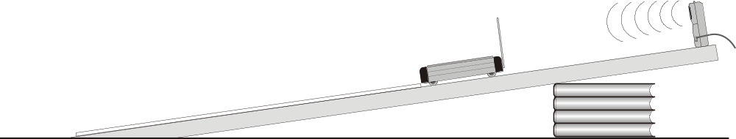
Figure 1

PROCEDURE
1. Set up a ramp using books as shown in the figure. The high end of the ramp should be 45 cm above the floor.
2. Tape a meter stick in the center of the ramp. Use two pieces of tape, one at each end of the meter stick. The 0 cm mark should be at the very bottom of the ramp. In this position, the meter stick will serve as a guide rail for your car.
3. Tape a card to the back of a car. The card serves as an ultrasound reflector.
4. Measure and record the mass of the car (in g).
5. Measure a distance 30 cm from the bottom end of the ramp. Mark this position with chalk or tape. Place the thick side of a 3-ring, hardback notebook on the 30 cm line, in a position where it will be struck in the center by the car rolling off the ramp.
6. Fasten the Motion Detector at the top and center of the ramp as shown in Figure 1. Connect the Motion Detector to the DIG/SONIC 1 channel of the interface.
7. Prepare the computer for data collection by opening the file “38 Momentum” from the Physical Science w Vernier folder. The vertical axis has velocity scaled from –0.5 to 3 m/s. The horizontal axis has time scaled from 0 to 3 seconds.
8. Place your car on the ramp with its front at the 40 cm line. Click  and release the car after you hear a sound coming from the Motion Detector. The car should hit the notebook. Measure and record the distance the notebook is pushed (to the nearest cm).
9. Click the Statistics button, . Record the maximum velocity in your data table.
10. Return the notebook to its original position. Repeat Steps 8 and 9.
11. Repeat Step 10. You should now have three trials for the 40 cm position.
12. Repeat Steps 8–11 at 60 cm and 80 cm positions.

DATA
Mass of the car (m) ______ g

Release Position

40 cm 60 cm 80 cm
Distance Notebook Moved
__________ cm __________ cm __________ cm
__________ cm __________ cm __________ cm
__________ cm __________ cm __________ cm

Release Position

40 cm 60 cm 80 cm
Velocity
__________ m/s __________ m/s __________ m/s
__________ m/s __________ m/s __________ m/s
__________ m/s __________ m/s __________ m/s

PROCESSING THE DATA
1. Calculate the average distance the notebook moved and the average velocity of the car as it hit the notebook for each release position. Record the results in the Data and Calculations Table above.

2. Calculate the momentum of the car for each release position using the formula p = mv, where p = momentum (in g•m/s), m = the car mass (in g), and v = velocity (in m/s). Use the average velocity values obtained in Step 1 above. Show your work below.
Release Position
40 cm 60 cm 80 cm

Momentum __________ g•m/s __________ g•m/s __________ g•m/s
3. Graph your results on Page 2 of the experiment file. Graph MOMENTUM (from Step 2) on the horizontal axis and the AVERAGE DISTANCE THE NOTEBOOK MOVED (from Step 3) on the vertical axis.
4. How did increased car momentum affect the distance that the notebook moved?

5. What happened to the velocity of your car as it was released from higher positions on the ramp?

6. How does increased velocity affect momentum?

7. Which is likely to cause more damage, a fast-moving car or a slow-moving one? Explain.

8. If the mass of the notebook would be doubled, what would happen to the distance it is pushed?

9. If the car’s mass would be doubled, what would happen to its momentum?

EXTENSION
1. Design an experiment to test your answer to Question 9 or 10.

